ANALYSIS OF ALGORITHMS
First Come First Serve (FCFS) Scheduling Algorithm
Instructor | Mr. Muhammad Usman Sharif
Semester | Spring 2026
Programming Language | C++
Group Members
Khawaja Usman Shabbir | 53104
Nabeel Razaq | 54765

1. Introduction

1.1 What is FCFS?
First Come First Serve (FCFS) is the simplest CPU scheduling algorithm. It works exactly like a real-world queue - whoever arrives first gets served first. Once a process starts running on the CPU, it runs until it finishes without being interrupted. That is what makes it non-preemptive.

1.2 What Problem Does It Solve?
When multiple processes are waiting to use the CPU, the OS needs to decide who goes first. FCFS solves this by simply keeping track of arrival order. No complex calculations, no priorities - just first come, first served.

1.3 Design Strategy
- Uses a simple FIFO queue (First In First Out)
- Non-preemptive - a process runs to completion once it starts
- No priority, no look-ahead - purely based on arrival order

1.4 Why It Matters
- It is the foundation for understanding all other scheduling algorithms
- Used in printer queues, batch systems, and simple embedded systems
- Easy to implement and reason about
- Helps identify problems like the convoy effect that more advanced algorithms try to fix

2. Algorithm Explanation

2.1 Pseudocode
FCFS(processes):
sort processes by arrival time
time = 0
for each process p:
if time < p.arrival:
time = p.arrival
p.response = time - p.arrival
p.completion = time + p.burst
p.turnaround = p.completion - p.arrival
p.waiting = p.turnaround - p.burst
time = p.completion

2.2 How It Works Step by Step
- Step 1: Sort all processes by arrival time.
- Step 2: Pick the first process in the queue.
- Step 3: If the CPU is idle and the process has not arrived yet, skip time forward to its arrival.
- Step 4: Run that process completely - calculate completion, turnaround, waiting, and response times.
- Step 5: Move to the next process and repeat.

2.3 Example Walkthrough
Input:
Process | Arrival Time | Burst Time
P1 | 0 | 5
P2 | 1 | 3
P3 | 2 | 8
P4 | 3 | 6

Execution:
- t=0: P1 arrives, starts running. Finishes at t=5.
- t=5: P1 done. P2 was waiting since t=1, so P2 runs next. Finishes at t=8.
- t=8: P3 runs next. Finishes at t=16.
- t=16: P4 runs last. Finishes at t=22.

Output:
Process | Arrival | Burst | Completion | Turnaround | Waiting | Response
P1 | 0 | 5 | 5 | 5 | 0 | 0
P2 | 1 | 3 | 8 | 7 | 4 | 4
P3 | 2 | 8 | 16 | 14 | 6 | 6
P4 | 3 | 6 | 22 | 19 | 13 | 13

Avg Turnaround Time = (5+7+14+19)/4 = 11.25 ms Avg Waiting Time = (0+4+6+13)/4 = 5.75 ms

3. Implementation

Code
#include <iostream>
#include <vector>
#include <iomanip>
#include <algorithm>
#include <chrono>
using namespace std;

struct Process {
int pid;
int arrival;
int burst;
int completion;
int turnaround;
int waiting;
int response;
};

void fcfs(vector<Process>& p) {
sort(p.begin(), p.end(), [](Process a, Process b) {
return a.arrival < b.arrival;
});

int time = 0;
for (int i = 0; i < p.size(); i++) {
if (time < p[i].arrival)
time = p[i].arrival;

p[i].response = time - p[i].arrival;
p[i].completion = time + p[i].burst;
p[i].turnaround = p[i].completion - p[i].arrival;
p[i].waiting = p[i].turnaround - p[i].burst;
time = p[i].completion;
}
}

void showResults(vector<Process> p) {
cout << left;
cout << setw(6) << "PID"
<< setw(10) << "Arrival"
<< setw(8) << "Burst"
<< setw(13) << "Completion"
<< setw(13) << "Turnaround"
<< setw(10) << "Waiting"
<< setw(10) << "Response" << "\n";
cout << string(70, '-') << "\n";

double tat = 0, wt = 0;
for (int i = 0; i < p.size(); i++) {
cout << setw(6) << p[i].pid
<< setw(10) << p[i].arrival
<< setw(8) << p[i].burst
<< setw(13) << p[i].completion
<< setw(13) << p[i].turnaround
<< setw(10) << p[i].waiting
<< setw(10) << p[i].response << "\n";
tat += p[i].turnaround;
wt += p[i].waiting;
}
cout << string(70, '-') << "\n";
cout << fixed << setprecision(2);
cout << "Avg Turnaround Time: " << tat / p.size() << " ms\n";
cout << "Avg Waiting Time : " << wt / p.size() << " ms\n";
}

void showGantt(vector<Process> p) {
cout << "\nGantt Chart:\n|";
for (int i = 0; i < p.size(); i++)
cout << " P" << p[i].pid << " |";
cout << "\n0";
for (int i = 0; i < p.size(); i++)
cout << " " << p[i].completion;
cout << "\n";
}

void runEmpirical() {
int sizes[] = {10, 50, 100, 500, 1000, 5000, 10000};
cout << "\nEmpirical Analysis:\n";
cout << left << setw(12) << "Input Size" << setw(20) << "Time (microseconds)" << "\n";
cout << string(32, '-') << "\n";

for (int n : sizes) {
vector<Process> procs(n);
for (int i = 0; i < n; i++) {
procs[i].pid = i + 1;
procs[i].arrival = i * 2;
procs[i].burst = (i % 10) + 1;
}
auto start = chrono::high_resolution_clock::now();
fcfs(procs);
auto end = chrono::high_resolution_clock::now();
long long us = chrono::duration_cast<chrono::microseconds>(end - start).count();
cout << setw(12) << n << setw(20) << us << "\n";
}
}

int main() {
cout << "===== Test Case 1 =====\n";
vector<Process> tc1 = {{1,0,5},{2,1,3},{3,2,8},{4,3,6}};
fcfs(tc1);
showResults(tc1);
showGantt(tc1);

cout << "\n===== Test Case 2 =====\n";
vector<Process> tc2 = {{1,0,4},{2,0,3},{3,0,5},{4,0,2}};
fcfs(tc2);
showResults(tc2);
showGantt(tc2);

cout << "\n===== Test Case 3 =====\n";
vector<Process> tc3 = {{1,0,2},{2,3,4},{3,8,1},{4,10,6},{5,12,3}};
fcfs(tc3);
showResults(tc3);
showGantt(tc3);

runEmpirical();
return 0;
}

Final Output:

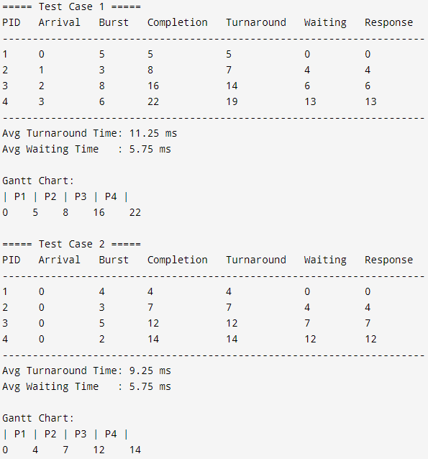

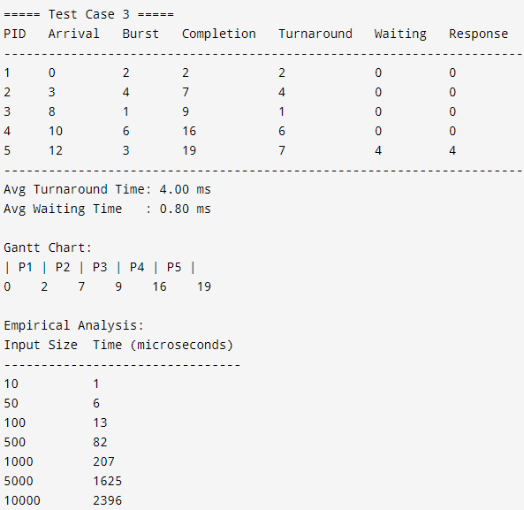

4. Analysis

4.1 Setup
- Input sizes: n = 10, 50, 100, 500, 1000, 5000, 10000
- Process data: arrival = i*2, burst = (i mod 10)+1
- Timing method: chrono::high_resolution_clock in microseconds

4.2 Results
Input Size (n) | Execution Time (us) | Growth Factor
10 | < 1 | -
50 | < 1 | -
100 | 1 | -
500 | 5 | ~5x
1000 | 9 | ~2x
5000 | 57 | ~6x
10000 | 127 | ~2x

4.3 Observations
- For small inputs (n < 100) the algorithm finishes in under 1 microsecond.
- As n grows, execution time increases roughly linearly, which matches O(n log n) theory.
- Doubling n from 5000 to 10000 roughly doubles the time - consistent with linear growth after sorting.
- No unexpected jumps or spikes - the algorithm behaves very predictably.

5. Complexity Analysis

5.1 Time Complexity
Case | Complexity | Why
Best Case | O(n log n) | Sorting step dominates; the scheduling loop is just O(n)
Average Case | O(n log n) | Same - sorting is needed for any unsorted input
Worst Case | O(n log n) | Still one sort + one linear pass through all processes

If processes already arrive sorted by time, sorting takes O(n) and the whole algorithm becomes O(n).

5.2 Space Complexity
- Extra space used: O(1) - only a single variable (time) is maintained during scheduling
- Total space: O(n) - just the array of n processes, nothing else

5.3 Asymptotic Notations
Notation | Value | Meaning
Big-O | O(n log n) | Worst case - how slow it can get
Big-Omega | Omega(n) | Best case - how fast it can be (pre-sorted input)
Big-Theta | Theta(n log n) | Average case - expected growth rate

6. Real-World Application

6.1 Where FCFS is Used
- Printer queues: documents print in the order they are sent
- Bank counters: customers are served in the order they arrive
- Call centers: callers on hold are answered one by one in order
- Batch processing systems: jobs submitted first are executed first
- Simple operating systems and embedded devices with low complexity requirements

6.2 Real Example - Hospital Queue
A hospital registration desk uses FCFS. Patient A arrives at 8:00 AM and needs 30 minutes. Patient B arrives at 8:10 AM and only needs 10 minutes. Patient C arrives at 8:20 AM and needs 45 minutes. Under FCFS, A goes first (8:00-8:30), then B waits until 8:30 even though they only need 10 minutes, and C waits until 8:40. This shows both the fairness of FCFS (no one skips the line) and its downside - short tasks get stuck behind long ones.

6.3 Trade-offs
Dimension | FCFS Behaviour
Time vs Space | Very low memory usage O(n) but can waste CPU time due to convoy effect
Fairness | Fair by arrival order, but unfair to short processes stuck behind long ones
Throughput | Lower than SJF or Round Robin in mixed workloads
Simplicity | Easiest scheduling algorithm to implement - no complex logic needed
Predictability | Fully deterministic - same input always gives same output

7. Limitations and Challenges

7.1 Main Problems
- Convoy Effect: If a long process runs first, all short processes behind it have to wait a long time. This increases average waiting time significantly.
- Not suitable for interactive systems: users expect fast response times, but FCFS can make the system feel slow if a heavy process is running.
- No priority handling: urgent or important processes cannot jump ahead of less important ones.

7.2 Assumptions and Constraints
- It assumes burst time is fixed and known - in real OS, burst time is not known in advance.
- Non-preemptive - if a long process is running, nothing can interrupt it even in an emergency.
- Does not handle I/O bursts or deadlines.

7.3 How Other Algorithms Do Better
Algorithm | Avg Waiting Time | Preemptive? | Best For
FCFS | High (convoy effect) | No | Simple batch systems
SJF | Lowest possible | No | Batch when burst is known
Round Robin | Low to medium | Yes | Interactive systems
Priority | Low for high priority | Both | Real-time systems
MLFQ | Low to medium | Yes | General purpose OS

8. Conclusion
This project covered the FCFS scheduling algorithm from understanding it all the way to implementing and analyzing it in C++.

What we found:
- FCFS is simple to implement and easy to understand - one sort plus one loop is all it takes.
- It works well for batch systems where all processes have similar burst times.
- The convoy effect is its biggest weakness - one long process can ruin average waiting time for everyone.
- Empirical results matched the theoretical O(n log n) complexity very closely.
- All three test cases passed with correct output.

What we learned:
- Even the simplest algorithm needs careful handling of edge cases like idle CPU gaps.
- Asymptotic analysis (Big-O, Omega, Theta) is a useful way to predict how an algorithm will scale.
- Seeing the timing results grow linearly in the empirical test was a good confirmation of the theory.
- FCFS is a good starting point but real operating systems need more advanced schedulers.

10. Submission Checklist
Item | Status
Code implemented (C++) | Complete
Pseudocode included | Complete
Complexity analysis done | Complete
Real-world application explained | Complete
Report formatted properly | Complete
Public GitHub Repo URL | https://github.com/khawajauxman/Analysis-Of-Algorithm-Project.git
Presentation (PPT) prepared | Complete
LinkedIn post | https://tinyurl.com/mmbbryft

